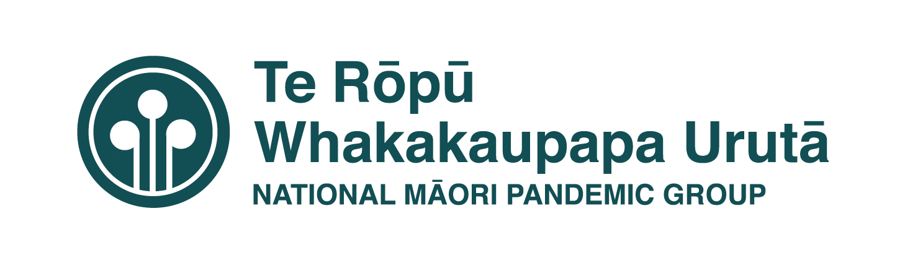

Analysis of Existing Health Sector Equity Tools

 | Reducing Health Inequalities Framework | Health Equity Assessment Tool – User’s Guide | Whānau Ora Health Impact Assessment | Equity of Healthcare for Māori: Framework | Central Region DHBs’ Equity Framework
Publication date: | 2 September 2002 | 1 July 2008 | April 2007 | 20 June 2014 | August 2019
Developed | Project led jointly by the Maori Health and Public Health Policy Groups of the Ministry of Health.  Input from the Ministry of Health expert advisory Group: Papaarangi Reid, John Broughton, Fiona Cram, Peter Crampton, Jackie Cummings, Chris Cunningham, Sitaleki Finau, Cheryl Hamilton, Phillipa Howden-Chapmen, Cindy Kiro, Margaret Southwark, Chris Webber. | The Health Equity Assessment Tool, (first published in May 2004), was used in the training workshops for the sector. The workshops were delivered by the Maori Health and Public Health Policy Groups of the Ministry of Health, Te Roopu Rangahau a Erū Pomare and the Public Health Consultancy.  Source: Te Roopu Rangahau a Erū Pomare, Ministry of Health and Public Health Consultancy 2003.  The User Guide was commissioned by the Ministry of Health and developed by Louise Signal, Fiona Cram and Bridget Robson in 2008. | Published by the Ministry of Health it is a formal approach to predict the likely health impacts of a policy on Māori and their whanau. Māori participation in the development process is a focus of the tool. It also identifies the role of the wider social determinants.  Developed with input from and external advisory group, an internal Ministry of Health advisory group, participants of “An Evaluation of the Whānau Ora HIA Assessment Guide”  The names of the individuals involved in the cited groups above are included in the document. | The framework is based on literature available at the time in the quality improvement field and research on improving access to health services for Māori, indigenous people and minority ethnic groups.  The research was commissioned by the Research and Evaluation Group in in Te Kete Hauora of the Ministry of Health and undertaken by Dr Fiona Cram (Katoa Ltd and focussed on diabetes, cancer and cardiovascular services, areas of high morbidity and mortality for Māori. | Commissioned by TAS Technical Advisory Service for DHBs, work undertaken by Wall Consultants Ltd.  Developed with input from Central Region DHB Chief Executives, COOs, GMs Maori, Pacific and Funding and Planning, and Clinicians.  The Framework uses the three action areas of leadership, knowledge and commitment mapped against the roles and responsibilities of funders and planners and clinicians using a Commissioning Framework – adapted from “Planning in a Commissioning Environment – A Guide” developed by the Australian Government Department of Health and Pricewaterhouse Coopers (PwC) 2016.
Origins | Builds on Mackenbach’s intervention framework (cited in National Advisor Committee on Health and Disability 1998):  1. Socioeconomic status,  2. Intermediary factors,  3. Health problems,  4. Feedback effect. | The tool was adapted from Bro Taf Authority, 2000. Planning for Positive Impact: Health inequalities impact assessment tool. Cardiff: Bro Taf Authority. | Builds on the Public Health Advisory Committee’s ‘A Guide to HIA: A Policy Tool for New Zealand ‘(2005). | Five reports outlining the research (and supplementing the framework) can be found at www.katoa.net.nz. They include three literature reviews, a report on the key information reviews and an overview of the findings of the entire research project. | Based on the Equity of Health Care for Māori: A Framework and commissioned by Research and Evaluation Group, Te Kete Hauora, Ministry of Health, and informed by an extensive literature review conducted by Fiona Cram (Katoa Ltd).
What is it | The framework for intervention entails developing and implementing comprehensive strategies at four levels.  - Structural – tackling the root causes of health inequalities, that is, the social, economic, cultural and historical factors that fundamentally determine health.  - Intermediary pathways – targeting material, psychosocial and behavioural factors that mediate the impact of structural factors on health.  - Health and disability services – undertaking specific actions within health and disability services.  - Impact – minimising the impact of disability and illness on socioeconomic position.  Intervention at these four levels should be undertaken nationally, regionally and locally by policy-makers, funders and providers. | The Health Equity Assessment Tool: A User's Guide, has been developed by the University of Otago, Wellington, to help facilitate the use of the Health Equity Assessment Tool (HEAT).  The Health Equity Assessment Tool: A User's Guide gives a brief overview of inequalities in health, introduces the HEAT and its use, presents an in-depth look at each of the HEAT questions, and provides case examples of the tool's use.  This publication is an essential guide for those working in the health and disability to apply a strong equity focus to their work. | The Whānau Ora HIA tool follows the same methodology outlined in the Public Health Advisory Committees’ A Guide to HIA: A Policy Tool for New Zealand’: screening scoping, appraisal and reporting and evaluation.  There are two major types of health impact assessment: policy level HIA and project level HIA. It is a systematic approach to identifying the likely impacts on the health and wellbeing of a population of any proposed policy, strategy, plan or project prior to implementation.  Once the impacts have been identified, a set of actions can be prepared to inform the decision-making process. There recommendations are evidence based and outcome focused. They propose practical ways to enhance the positive effects, for remove or minimise any negative impacts. | The Equity of Health Care for Māori: A framework guides health practitioners, health organisations and health system agencies to achieve equitable health care for Māori  There are three action areas that support the framework:  - Leadership – championing the provision of high-quality health care that delivers equitable health outcomes for Māori  - Knowledge – developing a knowledge base on ways to effectively deliver and monitor high quality healthcare for Māori  - Commitment – providing high quality health care that meets the health care needs and aspirations of Maori | The Equity Framework identified three commission roles:  - Strategic Planning  - Needs assessment  - Annual planning  - Procuring Services  - Designing and contracting services  - Shaping the structure of delivery  - Monitoring and Evaluation  - Managing performance  - Evaluation  The framework also includes a fourth element  Capability  - Capacity  - Training and Development
Usefulness | The Framework is useful as a starting point in understanding  It can be used to inform thinking about the development of interventions that try to address the complex contributors to health inequity. | This publication is an essential guide for those working in the health and disability to apply a strong equity focus to their work. | HIA is a flexible approach that can be modified to fit a specific context and task being assessed. It is scalable – mini, rapid, intermediate, comprehensive – considering timeframes, budgets and resource available.  While it is mostly used in other sectors, the methodology is robust and can be applied in the health sector at both a policy and project level. | The framework can be used by all parts of the health sector: health system agencies like PHARMAC, the Ministry of Health and regulatory authorities, health organisations: DHBs, PHOs, and other health providers and health practitioners: doctors, nurses and community health workers. | The Framework is being used by the Central Region DHBs HR teams to develop recruitment and retention strategies, equity competencies, training programmes and performance reviews that are focused on building equity capability in DHB staff.
Are there examples of it being used or adapted? | Used in DHB accountability and planning documents in conjunction with the HEAT Tool. | Yes – the guide provides examples | Examples of the WOHIA training programmes:  - Northland DHB Prioritisation Policy Whanau Ora HIA,  - Cultural and Clinical Nursing Support and Nursing support and training programme  - Draft Wairarapa Alcohol Strategy  - Location of the New Plymouth Oral Health Facility | It has been adapted to develop the Central Region DHBs Equity Framework.  It is very adaptable | The Framework is being used to strengthen the CRDHB regional plans.  It was used to inform the review of the Health and Disability safety standards
Score of usefulness | 4 | 8 | 7 | 8 | 8

